Design Idea #1 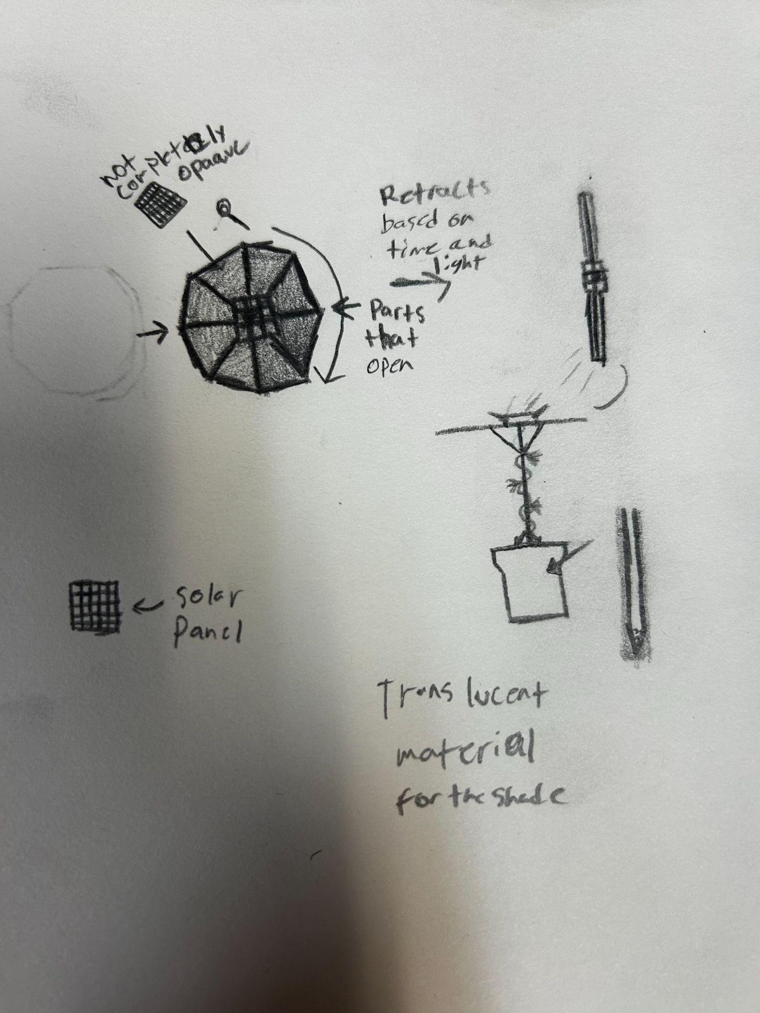
Date: 11/21/24
Description: Rotating umbrella
Drawing that includes distinguishing information such as scale, dimensions, and materials:
Design Idea #2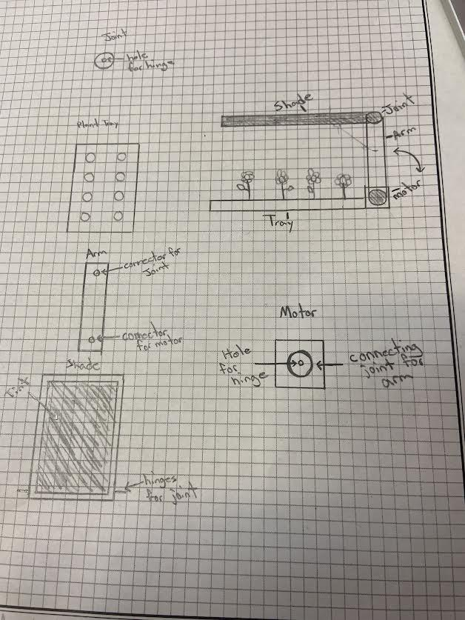
Date: 11/21/24
Description:
Drawing that includes distinguishing information such as scale, dimensions, and materials:
Design Idea #3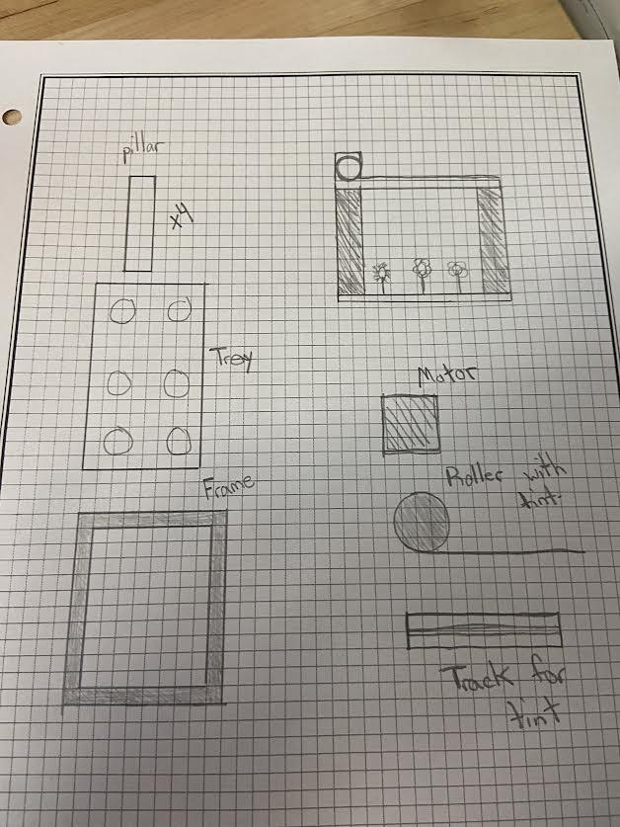
Date: 11/21/24
Description:

 | weight | Option 1 | Option 2 | Option 3 | Option 4
Criterion A | 0.33 | 5 | 4 | 5
Criterion B | 0.30 | 4 | 3 | 4
Criterion C | 0.20 | 3 | 3 | 3
Criterion D | 0.5 | 2 | 3 | 1
Criterion E | 0.5 | 1 | 2 | 2
Criterion F | 0.07 | 0 | 0 | 0
score | 100

Design Blueprint #1
Date: 12/10/2 4
Sketch:
Manufacturing Methods: Building, 3d printing
Step 1: Make the tray
Step 2: Make the arm/shade part
Step 3: install motor
Supply List and Costs:
Item | Cost each | # needed | Total
12V motor | 12-100$ | 1
2x4 | 3.00-30$ | 4
Paper towel roll | Free | 1
Plywood | 4.50-90$ | 1
Screws | 1.00-10$ | TBD
Canvas | .50-5.00$ | 1
Total Cost | 52 roughly

